**EECE5155: Wireless Sensor Networks and the Internet of Things**

**Numerical Homework Assignment**

**Liangshe Li**

In this assignment, you are going to be working on the design of a wireless sensor network for air pollution monitoring in cities. In this application, a large number of (ideally cheap) outdoor sensors deployed within a city (e.g., on building facades and rooftops, light posts, etc.) are periodically measuring the presence of pollutants in the air. The measured information is transmitted over the Internet to a cloud server, where data is both analyzed and stored.

Option A: LoRaWAN

Option B: IEEE 802.11ah

**PART 1**

In the first part of the assignment, you are going to quantitatively analyze the impact of different communication system parameters on the aforementioned application. For this, you can utilize MATLAB or any other numerical analysis toolbox (e.g., NumPy). Remember that MATLAB is available for free to all Northeastern students (check the Announcement on Canvas from September 11, 2020).

**Question 1: Compute and plot the path loss as a function of the transmission distance. Consider multi-path propagation with a reference distance of d0=1 m, and a propagation exponent of 𝛾=3.2. Nodes operate at the 900 MHz Industrial, Scientific and Medical (ISM) band, with omnidirectional antennas (Gtx=Grx=0 dBi). Please remember to label your axis, indicating both the magnitude and its unit (e.g., ‘Distance [m]’). (10 points)**

A: Set path losses as l, set transmission distance as d.

$$l(d)=\frac{P_{rx}(d)}{P_{tx}}=\frac{P_{tx}G_{tx}G_{rx}{\left(\frac{}{4πd}\right)}^{γ}}{P_{tx}}=G_{tx}G_{rx}{\left(\frac{}{4πd}\right)}^{γ}$$

$$l\left(d\right)\left[dB\right]=0{dB}_{i}+0{dB}_{i}+10*γ*\log{\frac{c}{4πfd}}=10*γ*\log{\frac{c}{4πfd}}$$

Bring in parameters and C=3*108 (m/s), we can get:

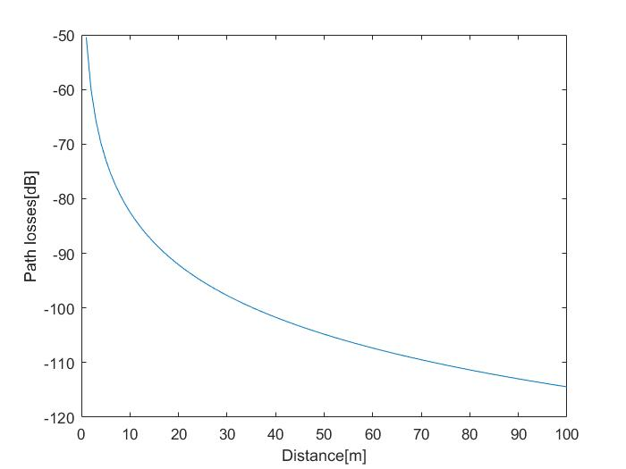

Matlab code:

Gamma=3.2;

c=3*10.^8;

f=9*10.^8;

d=0:100;

l=10*Gamma.*log(c./4./f./d./pi)/log(10);

plot(d,l);

xlabel('Distance[m]');

ylabel('Path losses[dB]');

To enable the communication between the nodes and ultimately the cloud, we consider two communication alternatives:

- Option A: Low-Power Wide Area Network based on LoRaWAN:

o Direct communication from each node to its closest base station (BS).

o Bandwidth: 500 kHz.

o Spreading factor: SF8

o Data-rate: 12.5 kilo-bits-per-second (kbps)

o The BS equivalent noise power of -100 dBm.

A signal to noise ratio of at least 20 dB is needed to ensure that the Bit Error Rate (BER) is of 10-5 at most.

**Question 2: What is the minimum received power at the BS needed to satisfy the BER requirement? (5 points)**

A: $SNR=\frac{P_{rx}}{N_{0}}=20dB={10}^{2}$ and $N_{0}=-100dBm={10}^{-10}mW$

So the minimum received power $\min_{}{{(P}_{rx})}={10}^{-10}mW*{10}^{2}={10}^{-8}mW=-80dBm$

**Question 3: Compute and plot the required transmission power as a function of the distance between a node and the BS. (5 points)**

A: Set the distance between a node and the BS as d.

$$P_{rx}\left[dBm\right]=P_{tx}\left[dBm\right]+G_{tx}+G_{rx}+20*\log{\frac{}{4πd}}$$

$$P_{tx}\left[dBm\right]=P_{rx}\left[dBm\right]-G_{tx}-G_{rx}-20*\log{\frac{c}{4πfd}}=-80dBm-0{dB}_{i}-0{dB}_{i}-20*\log{\frac{c}{4πfd}}=-80dBm-20*\log{\frac{c}{4πfd}}$$

Bring in parameters, we can get:

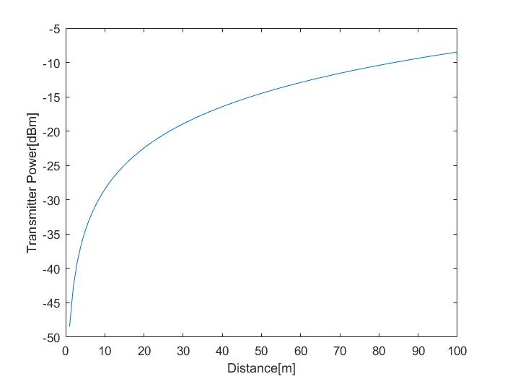

Matlab code:

c=3*10.^8;

f=9*10.^8;

d=1:100;

P_tx=-80-20.*log(c./4./pi./f./d)/log(10);

plot(d,P_tx);

xlabel('Distance[m]');

ylabel('Transmitter Power[dBm]');

**Question 4: If your maximum transmission power is 20 dBm, what should be the maximum separation between two BSs? (5 points)**

A: $P_{rx}\left[dBm\right]=P_{tx}\left[dBm\right]+G_{tx}+G_{rx}+20*\log{\frac{}{4πd}}$

$20\log{\frac{c}{4πfd}}=P_{rx}\left[dBm\right]-P_{tx}\left[dBm\right]-G_{tx}-G_{rx}=-80dBm-20dBm-0{dB}_{i}-0{dB}_{i}=-100dB$

So $\frac{c}{4πfd}={10}^{-5}$ so $d=\frac{c}{4*{10}^{-5}*π*f}$

Bring in parameters and compute, we can get d=2.65*10^3 m

And the maximum separation between two BSs should be two times of the maximum distance between a node and a BS, so the maximum separation is 5.3*10^3 m.

**Question 5: For the same transmission power, how much energy will a node consume when transmitting a 20 byte-long packet? At this point, ignore the energy consumption of acknowledgment frames or any other non-DATA message exchange. (5 points)**

A: 20 bytes = 160 bits. The data rate is 12.5 kbps. According to this two parameters, we can get the transmission time $t_{tx}=\frac{160}{12500}=1.28×{10}^{-2}(s)$.

The transmission power is 20 dBm = 100 mW = 0.1 W. So the energy needed is:

- Option B: Ad Hoc Network based on IEEE 802.11ah:

o Consider that instead of installing LoRaWAN BSs, you are deploying Access Points (APs) every 150 m.

o Bandwidth: 1 MHz.

o Data-rate: 300 kbps

o The equivalent noise power both at each node and at the AP is -80 dBm.

A signal to noise ratio of at least 20 dB is needed to ensure that the BER

is of 10-5 at most.

**Question 6: What is the minimum received power at any node needed to satisfy the BER requirement? (5 points)**

A: $SNR=\frac{P_{rx}}{N_{0}}=20dB={10}^{2}$ and $N_{0}=-80dBm={10}^{-8}mW$

So the minimum received power $\min_{}{{(P}_{rx})}={10}^{-8}mW*{10}^{2}={10}^{-6}mW=-60dBm$

**Question 7: Compute and plot the required transmission power as a function of the distance between two nodes. (5 points)**

A: $P_{rx}\left[dBm\right]=P_{tx}\left[dBm\right]+G_{tx}+G_{rx}+20*\log{\frac{}{4πd}}$

$$P_{tx}\left[dBm\right]=P_{rx}\left[dBm\right]-G_{tx}-G_{rx}-20*\log{\frac{c}{4πfd}}=-60dBm-0{dB}_{i}-0{dB}_{i}-20*\log{\frac{c}{4πfd}}=-60dBm-20*\log{\frac{c}{4πfd}}$$

Bring in parameters, we can get the plot below:

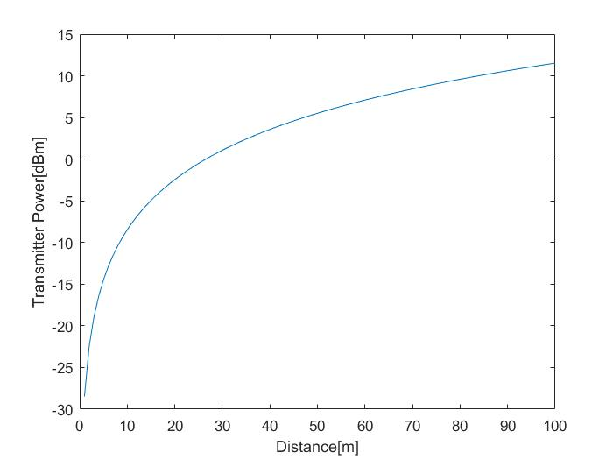

Matlab code:

c=3*10.^8;

f=9*10.^8;

d=1:100;

P_tx=-60-20.*log(c./4./pi./f./d)/log(10);

plot(d,P_tx);

xlabel('Distance[m]');

ylabel('Transmitter Power[dBm]');

**Question 8: If the maximum transmission power of each node is 10 dBm, how many transmissions will be required for a message from a node at 75 m to reach the AP? Remember that the number of transmission can only be an integer value. (5 points)**

A: $P_{rx}\left[dBm\right]=P_{tx}\left[dBm\right]+G_{tx}+G_{rx}+20*\log{\frac{c}{4πfd}}$

Bring in parameters (using min[prx]=-60dBm), we can get the minimum transmission power needed in the transmitter is:

$$\min_{}{P_{tx}[dBm]}=-60dBm-0{dB}_{i}-0{dB}_{i}-20*\log{\frac{3×{10}^{8}}{4×π×{9×10}^{8}×75}}=-60dBm+69dB=9dBm$$

Because the maximum transmission power of each node is bigger than the minimum transmission power needed, the number of transmission can only be one.

**Question 9: How much energy will be consumed to transmit 20 bytes from the node at 75 m to the AP? You can ignore the receiving and the computing power (they are comparably much lower than the transmission power). Similarly, at this point, ignore the energy consumption of acknowledgment frames or any other non-DATA message exchange. (5 points)**

A: 20 bytes = 160 bits. The data rate is 300 kbps. According to this two parameters, we can get the transmission time $t_{tx}=\frac{160}{300000}=5.33×{10}^{-4}(s)$.

From question 8, we can get $\min_{}{P_{tx}[dBm]}=9dBm$, and 9dBm=7.94mW

$$E_{tx}=\min_{}{P_{tx}}×t_{tx}=0.00794W×5.33×{10}^{-4}s=4.23×{10}^{-6}\left(J\right)=4.23 (μJ)$$

**Question 10: From the energy consumption perspective, which option would you prefer: A (LoRaWAN) or B (IEEE 802.11ah)? Briefly justify your answer. (10 points)**

A: I would select B (IEEE 802.11ah). First, from the result of Question 5 and Question 9, we can see under the same situation (the transmitter transmits a 20-byte-long packet ), the energy consumed in IEEE 802.11ah network is less. Second, iEEE 802.11ah protocol allow stations and AP to sleep longer so that it can save energy.

I would select A (LoRaWAN). First, from the result of Question 5 and Question 9, we can see under the same situation (the transmitter transmits a 20-byte-long packet ), the energy consumed in LoRaWAN network is less. Second, the link layer in LoRaWAN network is designed to allow low-powered devices to communicate with Internet-connected applications over long-range wireless connections, so the energy consumed by LoRaWAN network can be low.

**Bonus: Question 11: Intuitively (no need to redo the numbers, unless you really want to), what would happen if you were asked to operate the two networks at 2.4 GHz? Briefly explain your answer. (Bonus 5 points)**

A: If the two networks were operated at 2.4 GHz, the energy consumed by both two networks will decrease. According to the equation of path losses, if the operating frequency is higher and the transmitted power remain the same value, the received power will decrease, so it will save energy.

**PART 2**

In the second part of the assignment, you are going to qualitatively discuss some of the aspects relating to the link layer and above. Provide brief explanations for each question.

**Question 12: From the link layer perspective and, particularly, Medium Access Control (MAC), which network is easier to operate, a LoRaWAN network or an Ad Hoc IEEE 802.11ah network? In which network there will be a larger number of control and data messages being exchanged? (10 points)**

A: An Ad Hoc IEEE 802.11ah network is easier to operate. MAC in IEEE 802.11ah network is more efficient by reducing header side, aggregating acks, null data packets (no MAC content, only PHY, used for ACKs), and it will speed frame exchanges (multi-frame transmissions – sliding window).

LoRaWAN network will be a larger number of control and data messages being exchanged. Data messages in the frames of LoRaWAN network have some information such as Adaptive Data Rate (ADR), etc. LoRaWAN network also has 32 bits Message Integrity Check (MIC) in its frame to ensure security.

**Question 13: Explain the main differences between the network layer needed to support the LoRaWAN scenario and the one needed to support the IEEE 802.11ah network. In particular,**

**- How can a node know to whom relay its information?**

**- As a result, in which network do you expect more messages flowing? (10 points)**

A: (1) LoRaWAN network uses network layer security (NwkSkey) to authenticate the node in the network. LoRaWAN security is activated by Personalization (ABP) or Over The Air (OTAA). OTAA extracts and stores Device Address (DevAddr) via Join Process to know to whom relay its information. And then it will derive NwkSkey. ABP will produce NwkSkey through its production time to know to whom relay its information.

IEEE 802.11ah, like other Wi-Fi protocols, uses the Internet Protocol (IP) to know to whom relay its information. The source and destination have their own IP addresses. In a frame, there are three addresses using IP addresses to present the addresses of receiver, transmitter and final destination.

(2) LoRaWAN network will have more messages flowing. The frames of LoRaWAN network contain more messages, such as ADR, MIC, etc. Because of LoRaWAN network security, the nodes in the LoRaWAN network have more procedures to communicate, so LoRaWAN network has more messages flowing.

**Question 14: Focusing on the IEEE 802.11ah network, what type of routing protocol (i.e., proactive or reactive) would you utilize if:**

**- Sensors are periodically sending their measurements, independently of their value**

**- Sensors only send a message if the air pollution is above a certain safety limit (10 points)**

A: (1) If sensors are periodically sending their measurements, independently of their value, I would utilize proactive routing protocol, such as Optimized Link State Routing (OLSR). In the proactive routing, the information in the routing table is kept as accurate as possible during all the time to minimize the time between a packet is generated and the time the packet reaches the destination. Because sensors periodically send their measurements, using proactive routing can help to save time and collect the information of the entire network.

(2) If sensors only send a message when the air pollution is above a certain safety limit, I would utilize reactive routing protocol, such as Ad-hoc On-demand Distance Vector Routing (AODV). In reactive routing protocol, routes to a destination are discovered on demand, only if needed. It fits the situation that sensors only send a message when air pollution is above a limit.

**Question 15: Based on these discussions, which option would you prefer: A (LoRaWAN) or B (IEEE 802.11ah)?**

A: I prefer option B (IEEE 802.11 ah). First, IEEE 802.11ah is easier to operate from the link layer perspective. MAC in IEEE 802.11ah network is more efficient by reducing header side, aggregating acks, null data packets (no MAC content, only PHY, used for ACKs). And like other Wi-Fi protocols, IEEE 802.11ah uses IP addresses to authenticate the node in the network, which is an effective way to transport packets from source to destination. Furthermore, we can utilize different routing protocols when encountering different situations in in IEEE 802.11ah network. Besides, if we want to select one kind of network for Internet of Things (IoT), IEEE 802.11ah will be a good choice, because it is developed with IoT and it will save much energy. And relays are used to allow connectivity outside the coverage area, which can make packages transmit longer distance.